**PHPMYADMIN - Assignment**

**Process:**

**Set Up AWS Resources**

Logged in to AWS Management Console.  
• Launched EC2 Instance: (virtual machine - Ubuntu).

And security groups to allowed SSH (port 22) traffic with instance type - T2.medium and 15Gb disk size and created PPK file.

**Connect to Your EC2 Instance**

•    Used SSH to connect to EC2 instance using the PPK file via Putty

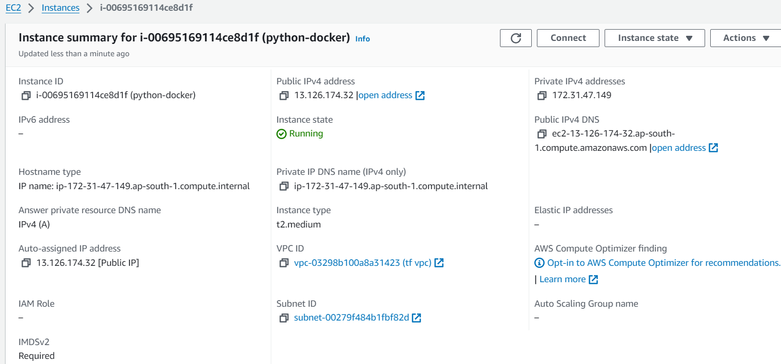

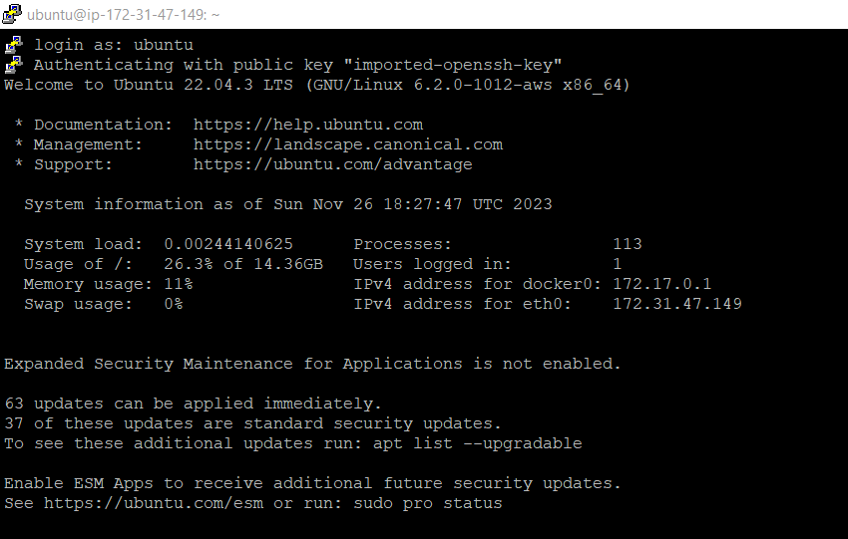

Here we are searching phpMyAdmin images in the docker hub using below command:

* **docker search phpMyAdmin**

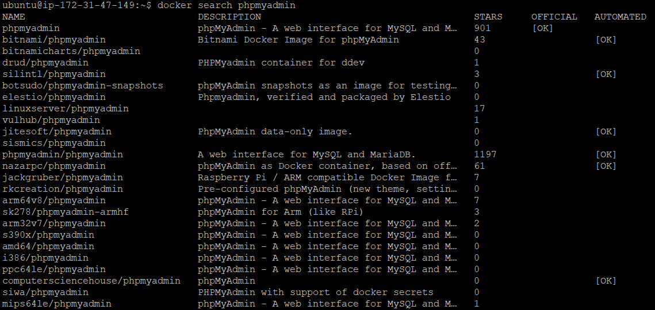

* **Pulling image from DockerHub**

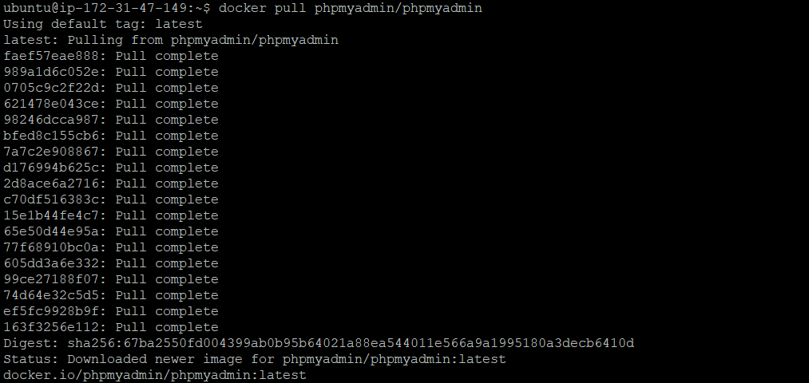

**Running pulled images with configuring mysql db -Password,network,container**

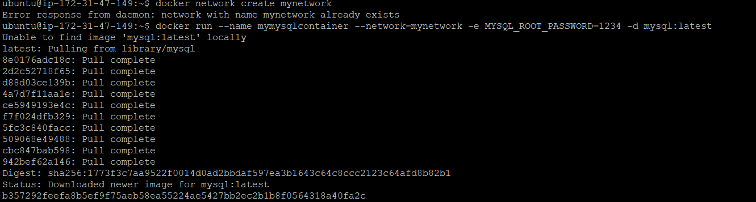

**After running image we got the containers in running state as below:**

**Command : docker ps**



**For Running image on browser(admin page) here we are using port mapping as below:**

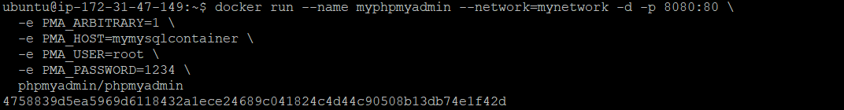

**Added 8080 port entry to Security group as below:**

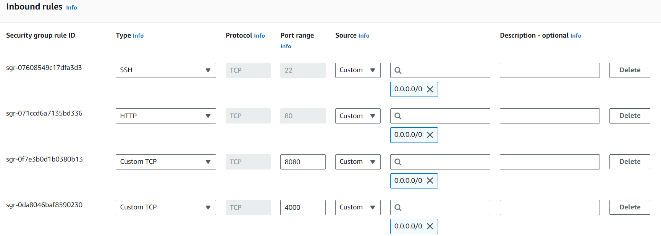

**FINAL Results:**

**phpMyAdmin page**

